# Day 4 - AD Cleanup Exercise

Every company that's grown for a few years accumulates accounts nobody remembered to clean up. This exercise seeds that realistic mess on purpose, then practices the actual remediation process, mirroring the Month 1 story's "AD cleanup" audit finding.

**Seed 10 intentionally disabled test accounts**
Create a list of users with uernames
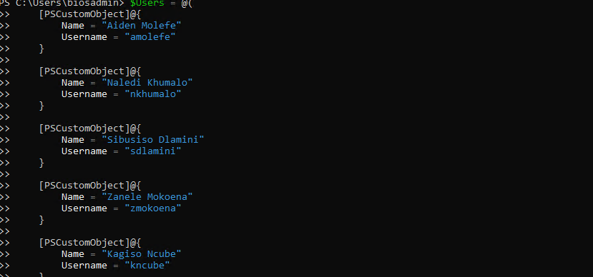
Use the dictionary to iterate the loop so it can create disabled accounts
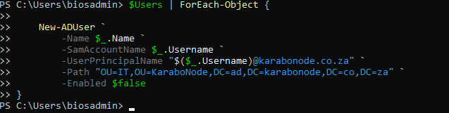
Query and export a report of disabled accounts:**
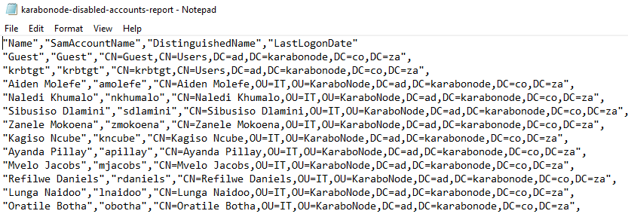
Remediations for the diables accounts in a real environment:
- **Move to a `Disabled` OU**
This will help when admin needs to see all the disabled accounts, by creating a new organisational Unit, it will help us organise and be able to track all users that are disabled. But there are several things we need to consider when moving a user to a disabled OU, Moving users doesn’t necessarily mean that the user will be removed of all his permission, you still need to disable the accounts, remove any group memberships, or access to sensitive resources.
- **Set a deletion timeline**
This is practiced if ever a user maybe was gone for a few weeks and requires their account to be enabled, so deleting it wouldn’t be a good choice, rather quarantine the account then wait 90 days or which ever retention policy the company has and delete the account after review. So its best you disable the account then delete it later on.
**Notify the manager**
Some times the accounts are disabled for a number of reason, like maybe the user is on leave, or switched departments, so its best to first contact the owner/manager and confirm if the accounts should be deleted before removing the account from the DC

## Why this matters
Directly matches the "AD cleanup tasks" line in the Azure & AD Specialist posting.

## Skills covered
`Search-ADAccount` for stale-account discovery, CSV reporting for audit evidence, writing remediation recommendations — the actual deliverable a real access-review finding produces, not just the query that found the problem.

